Applying for income assistance
- Create a BCeID for the individual applying https://www.bceid.c a/ choose Basic BCeID
- Sign up for MySelfServe https://myselfserve.gov.bc.ca
- Create an account, choose parent applying on behalf of a minor if under 18 or apply as the individual
- When applying, will need their SIN, PHN is optional, give a phone number that you will be likely to be able to answer. They will leave a message only twice, sometimes they leave no call back number, and if they don’t get in touch with you, you have to start the process over again.
- Wait for email to confirm email and set up a four digit PIN
- Wait again for registration to be processed (try again in one day)
- Log into MySelfServe, select Service Requests, then Create Service Request, check Apply for Assistance (you have 30 days to complete the application once you start)
- Go through the online application, you’ll need to send scans of
  - Social Insurance card or document with SIN on it
  - 2 pieces of ID (driver’s licence, BC ID, Passport, etc)
  - A photograph of applicant’s face
  - Download and sign prescribed class form (if this applies to applicant)
  - In living situation, check “renter”
  - Complete shelter form, DO NOT check “room and board”
  - Financial statements (bank accounts, savings accounts, any accounts that the applicant has (not the parent’s account))
    - Can get some of these through online banking but could also just go to the bank with the forms
- Wait for call

Applying for PWD
https://disability.benefitswayfinder.org/british-columbia/persons-with-disabilities-designation/
Here is how you will fill out the applicant’s section of the form.
The application form for the Persons with Disabilities (PWD) status has three sections:
Section 1 is the section you fill out. For help, you can view a Sample PWD application form.
Section 2 is the section your medical practitioner (doctor) or nurse practitioner fills out.
Section 3 is the section for an ‘assessor’ to fill out.
Definition: Depending on your disability, different professionals can fill out the form. They include:
- Medical Doctor
- Registered Psychologist
- Registered Nurse, Psychiatric Nurse, or Nurse Practitioner
- Occupational Therapist
- Physical Therapist
- Social Worker
- Chiropractor
- School Psychologist
Have you read and signed Section C – Declaration and Notification?
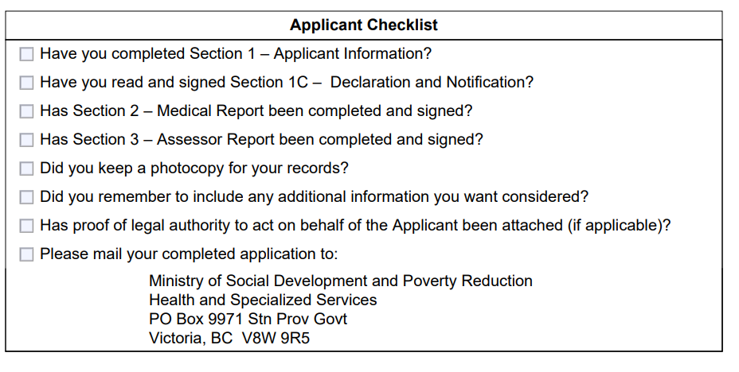

You can look at other benefits you may be able to get using the Benefits wayfinder.
Here are a few examples:
Endowment 150 benefit Endowment 150 offers eligible people with disabilities a one-time grant of $150 to help their Registered Disability Savings Plan (RDSP) grow.
Persons with Persistent Multiple Barriers (PPMB) - (B.C.) An alternate to the PWD designation (not in addition to it) is the PPMB. If you have long-term barriers to employment that are not expected to go away in the short term, you will be exempt from having to look for work. You may also be able to get a higher support rate and additional benefits.
BC Bus Pass Program Persons with Disabilities can receive a bus pass as part of their disability assistance.

